Advanced FortiGate Security Profiles

Team:
- Ayad Zewail
- Hazem Tawfik
- Mohamed Khaled
- Seif El-Tehewy
- Mostafa Mahmoud
- Youssef Osama

Background:
This project aims to utilize FortiGate’s capabilities with Web FIltering, Antivirus, and Application Control to enhance security in ways that facilitate operations for the cybersecurity engineers.

FortiGate is the firewall system developed by Fortinet and is one of the competing technologies alongside Cisco, Juniper, Plato Alto, etc. It has many features that allow it to be a useful security and network tool including VPN, Routing, Web FIltering, Application Control, Antivirus, and many other features.

The network that the FortiGate firewall will protect is a capstone CCNA project that will simulate a real network so that the firewall’s capabilities can be implemented and tested objectively.

Network Physical Topology:
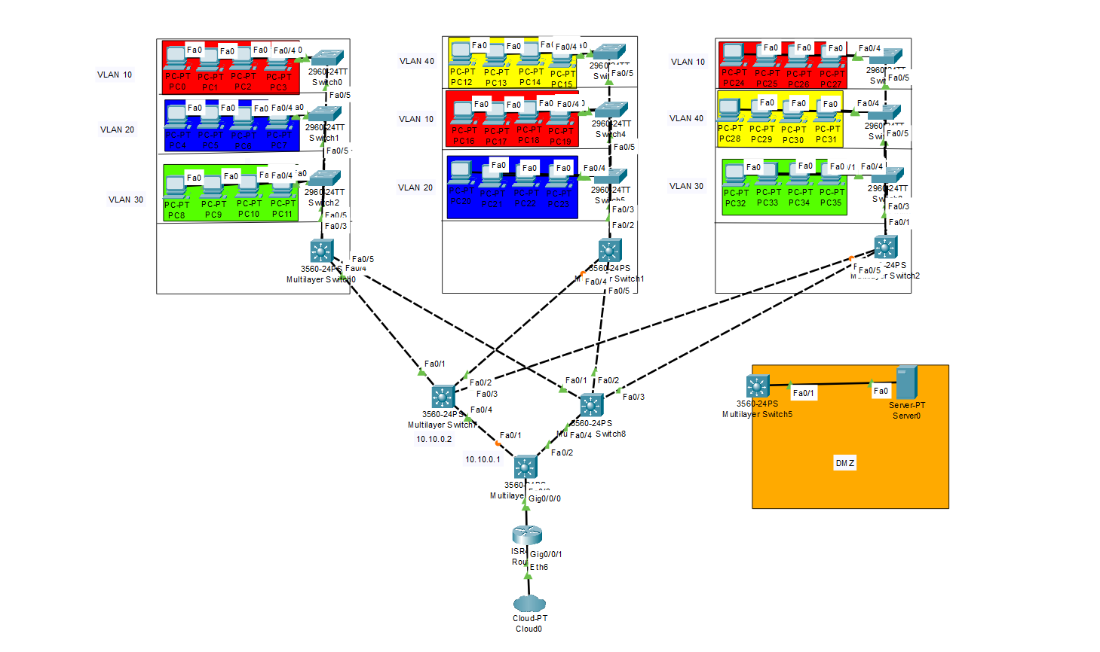
The network belongs to a company’s work site that consists of 3 buildings, each with 3 floors, that are interconnected with each other. Each building has departments that are separated through VLANs (10, 20, 30, and 40). The buildings aggregate each floor’s devices to a single multilayer switch on the ground floor that are also aggregated to a 2-MLS-Layer made for redundancy in case one of them fails. The core MLS acts as the mediator between them and the site router that connects the work site with the internet. A DMZ zone exists to house servers for the company to utilize and will eventually have a working DNS Server inside it.

Network Logical Topology:
Interconnects

R1 ↔ MLS-Core: 10.10.10.0/30
- R1 G0/0/0 = 10.10.10.1
- MLS-Core G0/0/0 = 10.10.10.2

R1 ↔ ISP/PT-Cloud: 200.0.0.0/30
- R1 G0/0/1 = 200.0.0.2 (NAT outside)
- ISP/PT-Cloud = 200.0.0.1

VLAN Subnets
- VLAN 10: 192.168.10.0/24 (HSRP VIP = 192.168.10.1)
- VLAN 20: 192.168.20.0/24 (HSRP VIP = 192.168.20.1)
- VLAN 30: 192.168.30.0/24 (HSRP VIP = 192.168.30.1)
- VLAN 40: 192.168.40.0/24 (HSRP VIP = 192.168.40.1)

Ideas for FortiGate Technologies

Web Filtering
  - Dynamic gathering of phishing links through web scraping for quick and periodic updates to the FortiGate web filtering system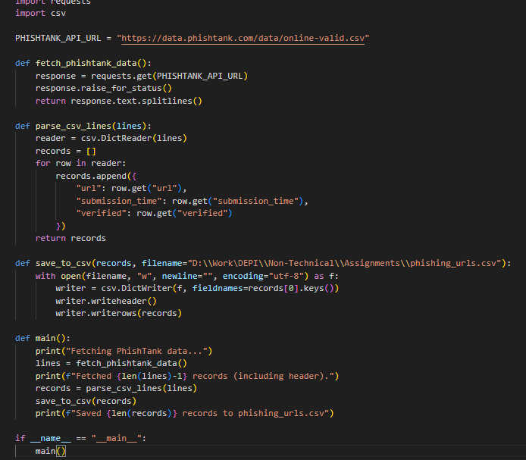Simple Prototype 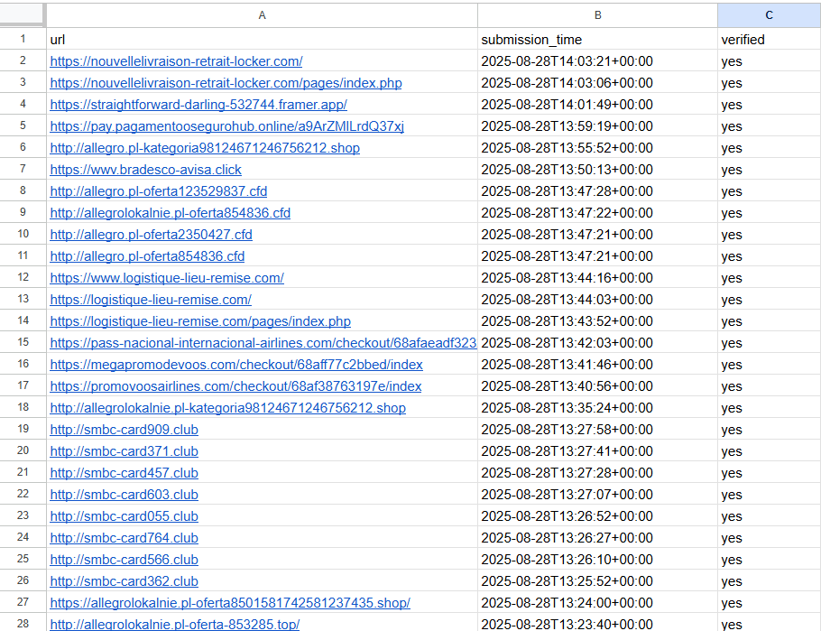ٌResult that can then be passed onto FortiGate

